1

**Exercise 4**

**Design a Sign-In and Sign-Up Page with**

**Navigation Bar using CSS**

**Objective:**

Create a web page with Sign-In and Sign_up form including horizontal navigation bar for any organization/industry as per your choice using HTML and CSS features such as CSS Position, Form Styles, CSS Pseudo classes that conforms to the following guidelines.

**Guidelines:**

* You need to design a single page website with horizontal navigation bar, Sign In and Sign Up forms with necessary CSS properties
* Create an **external CSS file with extension .css** and include it in HTML program using <link> tag as given below.
  + <https://www.w3schools.com/css/css_howto.asp>
* Horizontal Navigation Bar – Design the horizontal navigation bar using List of hyperlinks with proper CSS styles and position the same as “fixed”.
  + Refer this website for CSS position: <https://www.w3schools.com/css/css_positioning.asp>
  + Navigation Bar in CSS: <https://www.w3schools.com/css/css_navbar_horizontal.asp>
* Include **two cool background image** as banner images using DIV elements.
* Design a Sign-In and Sign-Up Box with necessary Input form elements with unique design (think some innovative design) and position the box using **relative** or **absolute** in the page.
  + Refer this for styling HTML forms: <https://www.w3schools.com/css/css_form.asp>
* Apply CSS properties to all the form elements to decorate it as per your choice.
  + Box Shadow: <https://www.w3schools.com/cssref/css3_pr_box-shadow.asp>
  + Rounded Corners: <https://www.w3schools.com/css/css3_borders.asp>
* Use pseudo class like focus and hover effects with form elements, button and navigation items.
  + <https://www.w3schools.com/cssref/sel_hover.asp>
  + <https://www.w3schools.com/cssref/sel_focus.asp>

Note: Refer the next pages for the sample designs (just a reference only – create your unique design with background images and colors, etc..

**Sample Designs for reference only**

Design 1

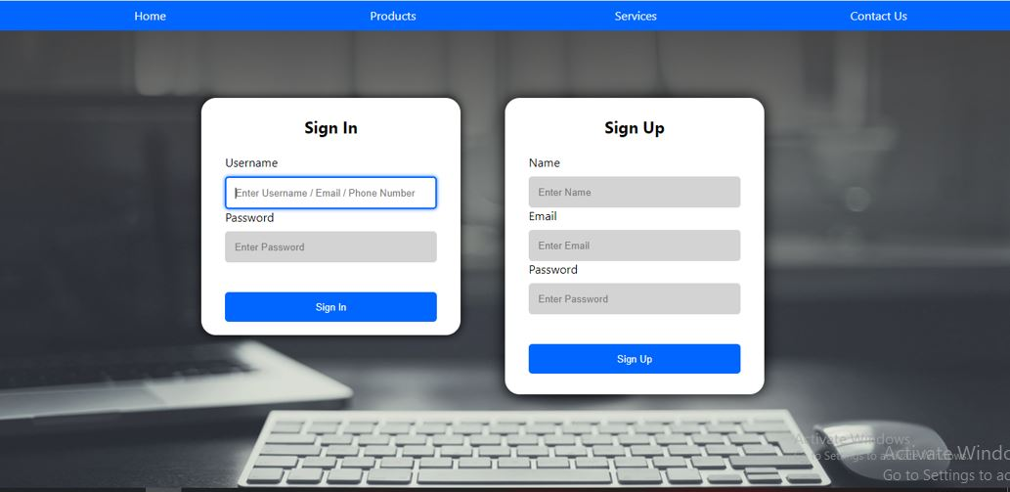

Design 2

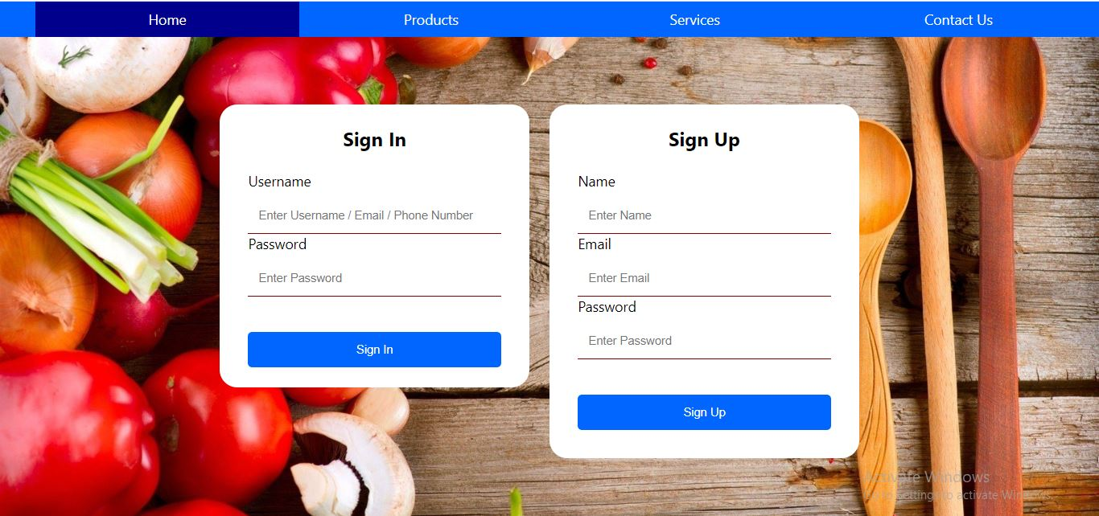

Design 3

